


Recognised Professional
Qualification Guide for
Chartered Institution of Civil Engineering Surveyors - CICES

Eligibility

To be eligible for RICS membership though a Recognised Professional Qualification, you must:
- meet the qualification and experience requirements set out on here Recognition of Professional Qualifications for MRICS
- not have been referred on a chartered assessment if you are applying for MRICS
Some Recognised Professional Qualification arrangements include a condition that requires applicants to have a period of relevant experience. Where this is stated, RICS
defines “relevant experience” as full-time and relevant to the RICS competencies as set out in the appropriate RICS pathway guide. You can find the pathways guide here to see the relevant competencies. If you have any questions about the relevance of your
experience, please contact us.

Important note: All RICS Recognised Professional Qualification routes are reviewed on a regular basis and are subject to change/closure at short notice. Where appropriate, RICS will honour any Recognised Professional Qualification application in process at the time of any change/closure.
RICS reserves the right to decline any application, including but not limited to if the applicant has been previously referred at an RICS assessment.

Important links
RICS webpage to review our - Recognition of Professional Qualifications Apply for the Chartered Recognised Professional Qualification

Contact details
You will notice at the top of each page a summary of the steps required to complete your application.
On the right-hand side, you will see confirmation of information normally required during the online application.

As a CICES member you are not required to provide a Letter of Good standing as your membership status will automatically be verified directly with the CICES.
Instead, please you CPD record demonstrating a minimum of 20 hours CPD in the last 12 months. You must upload this before you can proceed with your application.
Please complete your personal contact details.
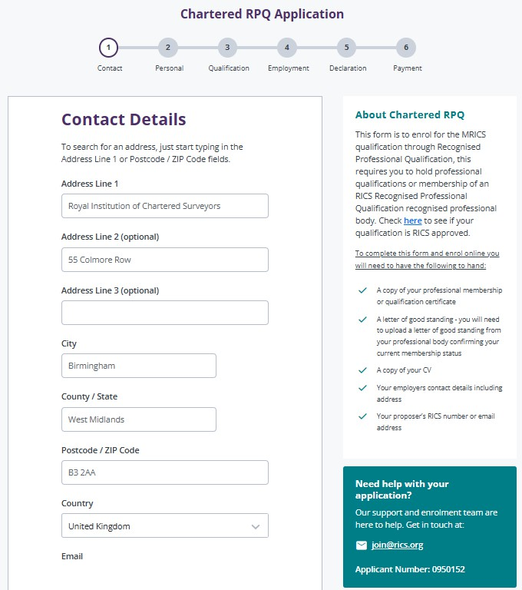

At the bottom of each page you can select ‘next’, ‘back’ or ‘save for later’ if you wish to return to the application.


Personal details

Please complete your personal details
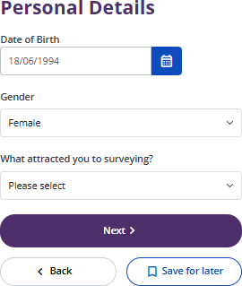

Qualification details

Select Chartered Institution of Civil Engineering Surveyors (CICES) from the drop down.

Instead of providing your ‘Letter of good standing’ this is where you will need to upload your CPD record demonstrating a minimum of 20 hours in the last 12 months
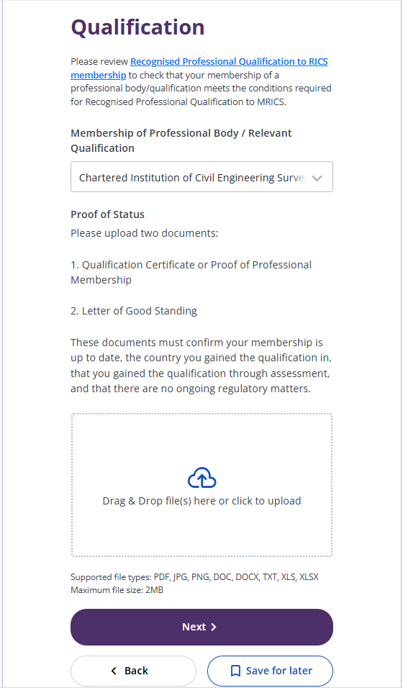

Employment

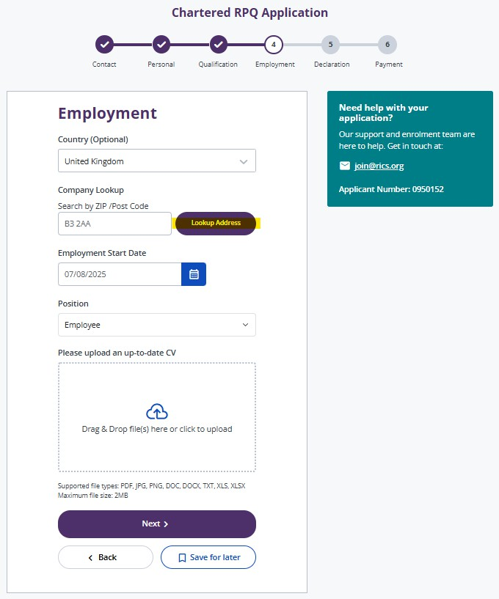
Please search using the country and ZIP/post code, we may have your company already in our database.

If you are unable to find your company in our database, please tick the highlighted box to manually provide these details.
At this stage you are also asked to provide us with an upto date CV, this is used to verify your eligibility to our Recognised Professional Qualification requirements.
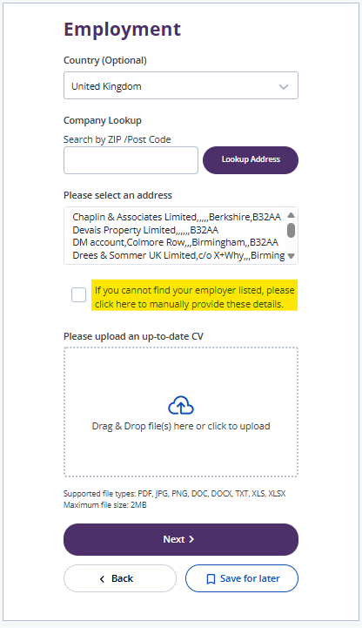

Declaration

Please ensure you read the declaration thoroughly, responding to the questions truthfully
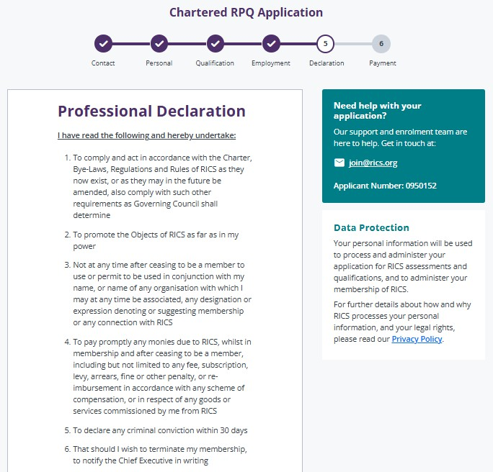

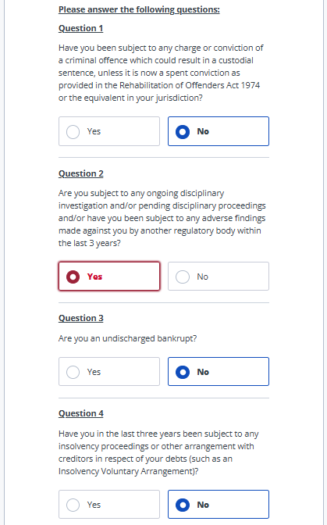

If your response to any of the above questions is ‘yes’ please provide our Regulation Team with further details on the relevant matter. You can contact them at
declarations@rics.org.
Until our Regulation Team have concluded their review your application will be placed on hold.

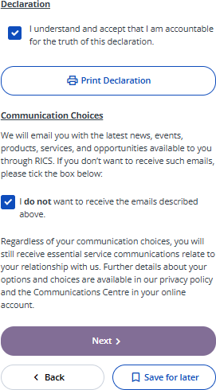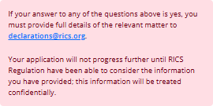

Vetting

Following completion of the declaration, your application will be reviewed by an RICS colleague. They will verify your eligibility using the evidence provided, ensuring you meet the RPQ requirements to proceed.
A response will be provided within 5 working days, confirming our approval or seeking further information.
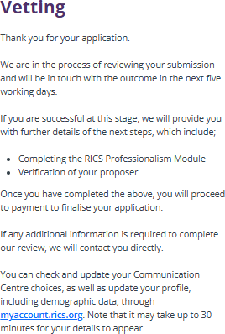

Assessment Platform

Once your application has been vetted and approved, you will receive an email directing you to the Assessment Platform. Here you will be required to complete:
  - RICS Professionalism Module
  - Provide your Proposer’s details

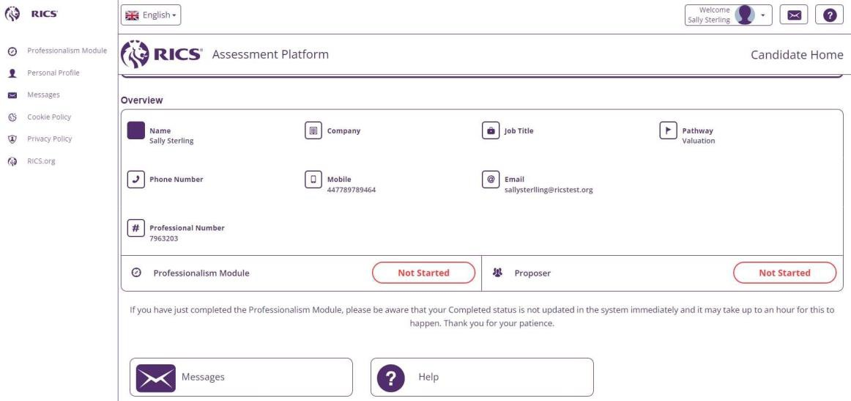

Enter your Proposer’s information as shown below, using the confirm button once the Proposer’s full details are shown


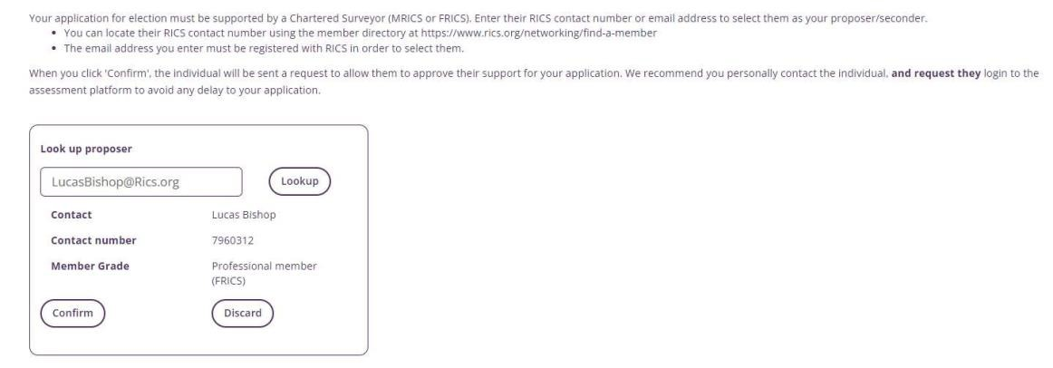

An electronic notification will be sent to your Proposer, to verify they are willing to support your application.

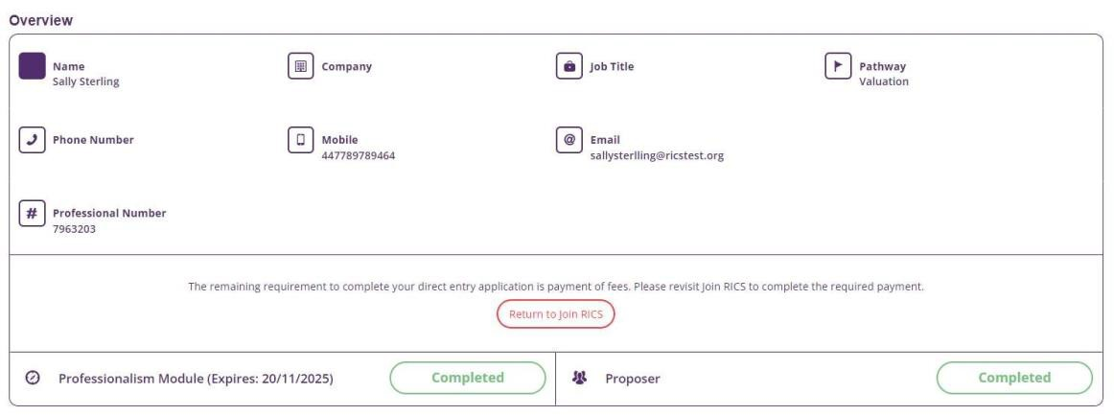

Once your Proposer has confirmed they are willing to support, you will see both requirements are shown as complete and you are now asked to make the required payment.

Payment

You will be directed to return to your RICS.org account to make the required online payment.
The fee relevant to your application will be £750.00 for MCInstCES or £875.00 for FCInstCES minus any subscriptions you have already paid that year to CICES.

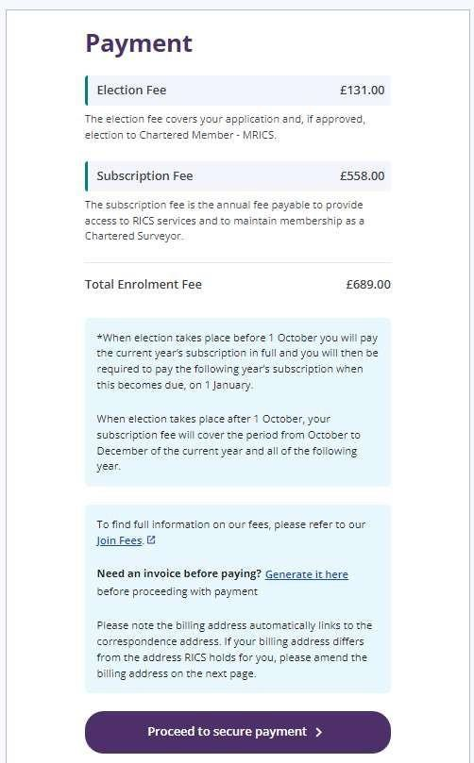

£136

Next Steps

Congratulations on completing the online application and securing your RICS status, a welcome email will follow in the next 24 hours. Your RICS Membership Certificate should be received within 6-8 weeks.

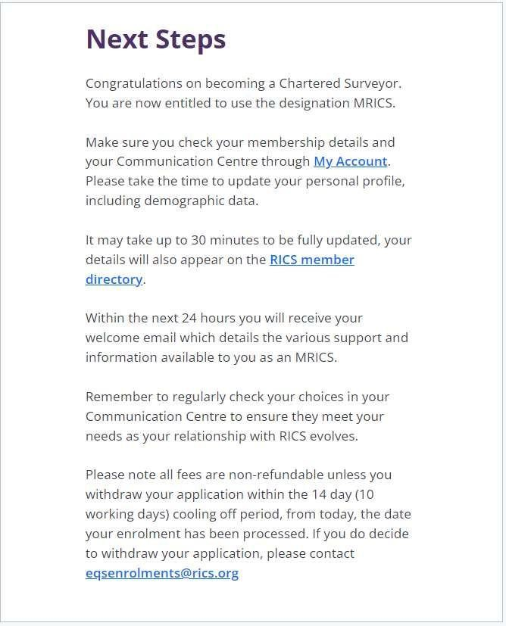

Delivering confidence
We e RICS. As amember-led chartered professional body wo King int e public imerest. we upho'd the highest tech ical and echlcal standards. v,.e 1nsp1re profession Iism, advance knowledge and suppon. our members across glob I m keLS co make an effecr1ve comriburio for the benefit of society.
We lndepe dem1y reg I te our me bers I the an gemem
ofland, real es,ate, co srrumon and nfras,ruccure. Our work with ochers supports their professio al p ct"ce and p[o eers a narural and built environment that is sustainable, resilie c and inclusive for all.

Americas, Europe, Middle East & Africa
aemea@rics.org

Asia Paci ic
apao@rics.org

United Kingdom & Ireland
contactrics@rk:s.org


ncs.org

